AP Calc AB Name: _______________

______________ _____________

WS Assessment

Target 21:

Position, velocity and Acceleration using integral

**I can:**

* Determine the average value of a function using definite integrals
* Determine values for positions and rates of changes using definite integrals
* Interpret the meaning of definite integral in accumulation problems

Unit 8: Applications of Integration

HW Target 21 Unit 8 Progress Check MCQ

To find the average value of a set of numbers, you just add the numbers and divide by the number of numbers. How would you find the average value of a continuous function over some interval? The problem is that there are an infinite number of numbers to add up, then divide by infinity. One approach is to divide up the interval and use n left or right samples of the value of the function, add them up, then divide by n. If we take the limit as n approaches infinity, then we will get the average value. The formula for the average value of a function, f, over the interval from a to b is:

ave value rewritten

One way to think about this is to rewrite this formula as

Think of (b - a) as the width of a rectangle, and average as the height. Then the average value of a function on an interval is the height of a rectangle that has the same width as the interval and has the same area as the function on that interval.

Determine the average value of the following functions on the given interval

f(x) = x2 – 5x + 6 cos($π$ x) on [-1. 2.5] g(x) = sin(2x)e 1 – cos(2x) on [- $π, π]$

The amount of energy associated with a certain chemical reaction is given by *E* = *x* ln *x*,   
where 1 ≤ *x* ≤ *e*, and *x* represents the amount of one of the reactants. Find the average energy of the reaction over the range of possible levels of reactant.

The Mean Value Theorem for Integrals: If f(x) is a continuous function on [a,b] then there is a number c in [a,b] such that $\int_{a}^{b}{f\left(x\right)dx=f(c)(b-a)}$

Determine the number c that satisfies the Mean Value Theorem for Integrals for the function

*f*(x)= x2 + 3x + 2 on [1,4] *f*(*x*) = 6*x*2 – 8*x* + 1 on [-1, 1]

Motion

Speed vs Velocity

Distance vs Displacement

A particle moves along the x-axis with the position function is x(t) and the velocity is v(t). At the time t = 2, the particle is located at x = 5. Given the velocity graph, find the following

At the time t = 7, distance travel _______ displacement ______

At the time t = 6, speed ________ velocity _____________

A particle moves along the x-axis with the position function is x(t) and the velocity is v(t). Describe the meaning of the following in its context

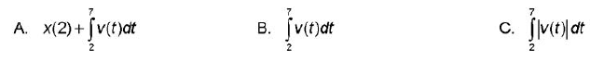

A particle moves along the x-axis with the position function is x(t) and the velocity is v(t). At the time t = 2, the particle is located at x = -1. Given the velocity table, find the following

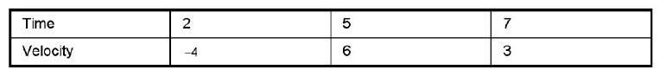

At the time t = 7.   
Position Distance travel Displacement

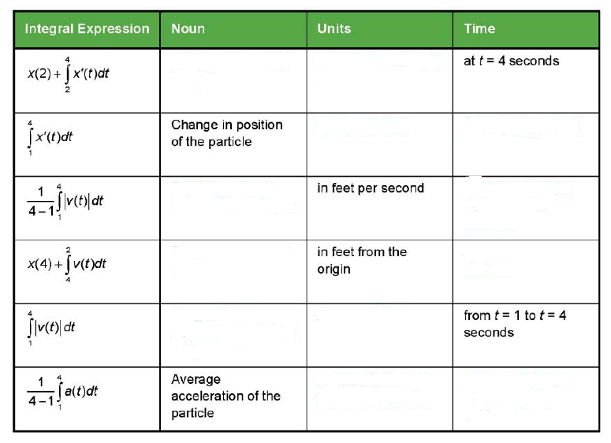The position of a particle moving on the x-axis, in feet from the origin, is given by x(t), velocity v(t) in feet per second and the acceleration a(t). Fill in the empty box.



Distance Traveled Displacement

The velocity v of an object traveling on a straight line is given by v(t) = t2 – 3t + 2 (m/sec). In the indicate interval $0<t≤3$ Find and draw to illustrate

a. The distance traveled by the object. b. The displacement of the object.

The velocity v of an object traveling on a straight line is given by v = | t – 5| (m/sec). In the indicate interval $0<t≤8$ Find and draw to illustrate

a. The distance traveled by the object. b. The displacement of the object.

A body moves on the x-axis with acceleration a(t) = 6t (m/sec2). It starts at time t = 0 with initial velocity v0= –3 m/sec.   
a. Find the velocity v(t) as a function of t.

b. Find the total distance s traveled by the body from time t = 0 sec to time t = 4 sec.

c. Where is its position at time t = 4 sec relative to its position at time t = 0 sec?

An object moves on a straight line with velocity v(t) = 2e-t (km/h) for t > 0.

a. Find the distance s(t) the object has moved as a function of time t.

b. How far does the object move throughout eternity?

An object traveling on the x-axis with velocity $v\left(t\right)=cos⁡(\frac{πt}{3})$ (m/sec).

a. What is its direction and speed at the time t = 0 sec?

b. What is its direction and speed at the time t = 3 sec?

c. Find the distance it has traveled from the time t = 0 sec to time t = 3 sec

d. Where is it at the time t = 3 sec?

The acceleration function of a moving particle on a coordinate line is a(t) = – 4 and v0=12 for

0 ≤ t ≤ 8. Find the total distance traveled by the particle during 0 ≤ t ≤ 8.

The velocity function of a moving particle on a coordinate line is v(t) = 3 cos(2t) for 0 ≤ t ≤ 2π.

a. Determine when the particle is moving to the right.

b. Determine when the particle stops.

c. The total distance traveled by the particle during 0 ≤ t ≤ 2π.

Matching

A pipeline company manufactures pipe that sells for $100 per meter. The cost of manufacturing a portion of the pipe varies with its distance from the beginning of the pipe. The company reports that the cost to produce a portion of the pipe that is *x* meters from the beginning of the pipe is *C(x)* dollars per meter. (Note: Profit is defined as the difference between the amount of money received by the company for selling the pipe and the amount it costs to manufacture the pipe.)



Recall $\int_{a}^{b}{f^{'}\left(x\right)dx=f\left(b\right)-f(a)}$ We then have $f\left(a\right)+\int_{a}^{b}{f^{'}\left(x\right)dx=f(b)}$

Example: If the initial population of a town is 5500 and the population is changing at the rate dP/dt people per year, then $5500+\int_{0}^{10}{P'(t)dt}$ will determine the population of the town after 10 years

There are 30 gallons of pollutant in a latke at t = 0. If the number of gallons, P(t) of the pollutant changes at the rate $P^{'}\left(t\right)=1-3e^{-0.3\sqrt{t}}$ gallons per day. What is the amount of pollutant in the lake after 12 days?

Water is leaking from a tank at the rate of $\sqrt{t+1}$ gallons per minute. Ten minutes after the leak is discovered, there are 60 gallons of water in the tank. How much water was in the tank when the leak was initially discovered?

**Assessment**

(2005#2) The tide removes sand from Sandy Point Beach at a rate modeled by the function R given by R(t) = 2 + 5 sin (4πt/25). A pumping station adds sand to the beach at a rate modeled by the function S given by S(t) = (15t)/(1 + 3t).

Both R(t) and S(t) have units of cubic yard per hour and t is measured in hours for 0 ≤ t ≤ 6.

At the time t = 0 the beach contains 2500 cubic yards of sand.

a. How much sand will the tide remove from the beach during this 6-hour period?

b. Write the expression for Y(t), the total number of cubic yard of sand on the beach at time t

c. Find the rate at which the total amount of sand on the beach is changing at time t = 4

d. For 0 ≤ t ≤ 6, at what time t is the amount of sand on the beach a minimum? What is its value?

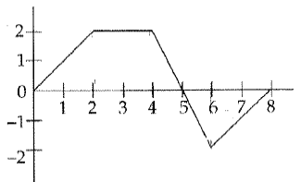The velocity in meter per second of a particle moving a long the x axis is shown. Find the total displacement of the object in the time interval from 0 to 8. Find the total distance travel of the object in the time interval from 0 to 8. When does the object move forward, backward, speed up, slow down, stand still? When does object at its greatest speed? When the acceleration is positive? Negative?

A pie is removed from an over and, after sitting for 10 minutes, is at a temperature of 200 degrees Fahrenheit. The pie cools at a rate of 3ln(t2) degree per minute. What is the expected temperature of the pie 15 minutes after it was removed from the oven?

Throughout the day, people have entered a craft fair at the rate of E(t) = 30t2+16t people per hour and have exited at a rate given by L(t) – 12t -2 people per our. If t is measured in hours since the fair opened, and there were 200 people at the fair at the end of the first hour, how many people should be at the fair 3 hours after it opened?

